A Project Report

on

House Price Prediction Using
Machine Learning
carried out as part of the Project Based Learning-3 (DSE3170)
Submitted

by

Nishant Choudhary (23FE10CDS00331)
Niksh Bhati (23FE10CDS00335)
Swagat Mohanty(23FE10CDS00306)

in partial fulfilment for the award of the degree of

Bachelor of Technology

in

Computer Science and Engineering (Data Science)

Under the Guidance of
Guide Name



School of Computer Science and Engineering
Department of Data Science and Engineering

MANIPAL UNIVERSITY JAIPUR, JAIPUR
RAJASTHAN, INDIA

November 2

ABSTRACT
Predicting house prices is an important task in the real estate industry. Accurate house price estimation helps buyers, sellers, and investors make informed decisions. Traditionally, house prices are estimated based on market trends, expert opinions, and historical data. However, these methods may not always provide precise predictions.
In this project, machine learning techniques are used to predict house prices based on various property features such as area, number of bedrooms, bathrooms, parking spaces, and other facilities. The dataset used for this study is obtained from Kaggle and contains information about different housing properties and their prices.
The project follows a complete data science workflow including data preprocessing, exploratory data analysis, model building, and model evaluation. Two machine learning algorithms were implemented: Linear Regression and Random Forest Regressor.
The performance of the models was evaluated using Mean Squared Error (MSE) and R² score. The Random Forest model performed better compared to Linear Regression due to its ability to capture complex relationships between variables. The results show that factors such as area, number of bathrooms, and availability of air conditioning significantly influence house prices.
This project demonstrates how machine learning can be effectively applied in real-world real estate price prediction problems.

Introduction
The real estate market is one of the most significant sectors of the global economy. Property prices are influenced by various factors such as location, infrastructure, property size, number of rooms, and additional facilities.
Traditionally, real estate prices are estimated by property agents or through comparative market analysis. However, these methods can sometimes be subjective and inaccurate. With the advancement of machine learning and data analytics, it is now possible to build predictive models that can estimate house prices more accurately based on historical data.
Machine learning algorithms can analyze large datasets and identify patterns between property features and their prices. By training predictive models on historical housing data, it becomes possible to estimate the price of new properties with reasonable accuracy.
The aim of this project is to develop a machine learning model capable of predicting house prices using different property attributes. The project also demonstrates how data preprocessing, exploratory data analysis, and model evaluation are important steps in building a reliable prediction system

Problem Statement
The real estate market often faces challenges in accurately estimating property prices. Buyers may overpay for houses, while sellers may undervalue their properties.
The problem addressed in this project is to develop a machine learning model that can predict house prices based on various housing features such as area, number of bedrooms, number of bathrooms, availability of parking, and other amenities.
The goal is to create a model that can learn from historical housing data and provide accurate predictions for new properties.

Objectives of the Project
The main objectives of this project are:
• To analyze housing data and identify important features affecting house prices.
• To preprocess the dataset and prepare it for machine learning algorithms.
• To perform exploratory data analysis to understand relationships between variables.
• To build machine learning models for predicting house prices.
• To evaluate the performance of different models and compare their accuracy.

Literature Review
Several studies have explored the use of machine learning techniques for predicting house prices. Traditional statistical models such as linear regression have been widely used for price prediction due to their simplicity and interpretability.
Recent research has shown that machine learning algorithms such as Random Forest, Decision Trees, and Gradient Boosting can provide better prediction accuracy compared to traditional models. These algorithms are capable of capturing complex relationships between features that linear models may fail to detect.
Studies have also highlighted the importance of data preprocessing and feature selection in improving prediction performance. Exploratory data analysis helps in understanding the dataset and identifying the most influential factors affecting house prices.
The use of machine learning in real estate price prediction has gained significant attention due to the increasing availability of large housing datasets and improved computational capabilities.

Dataset Description

The dataset used in this project was obtained from Kaggle and contains information about housing properties and their prices.
The dataset includes 545 records and 13 features. Each record represents a house and its associated attributes.
The features in the dataset are:
Area – Size of the house in square feet.
Bedrooms – Number of bedrooms in the house.
Bathrooms – Number of bathrooms.
Stories – Number of floors in the house.
Parking – Number of parking spaces available.
Mainroad – Indicates whether the house is connected to the main road.
Guestroom – Indicates whether the house has a guest room.
Basement – Indicates the presence of a basement.
Hotwaterheating – Indicates whether hot water heating is available.
Airconditioning – Indicates whether air conditioning is available.
Prefarea – Indicates whether the house is located in a preferred residential area.
Furnishingstatus – Describes whether the house is furnished, semi-furnished, or unfurnished.
Price – Target variable representing the price of the house.

Data Preprocessing

Data preprocessing is an important step in machine learning as raw data often contains inconsistencies or categorical values that cannot be directly used by machine learning algorithms.
The following preprocessing steps were performed:
First, the dataset was loaded using the pandas library. The dataset was examined using functions such as info() and describe() to understand the structure of the data.
Next, missing values were checked using the isnull() function. The dataset did not contain missing values, so no additional handling was required.
Categorical variables such as mainroad, guestroom, basement, airconditioning, and furnishingstatus were converted into numerical values using Label Encoding. This step allows machine learning algorithms to process categorical features effectively.
Finally, the dataset was separated into input features (X) and the target variable (y).

Exploratory Data Analysis

Exploratory Data Analysis (EDA) was performed to understand the patterns and relationships within the dataset.
Several visualization techniques were used:
Correlation Heatmap – Shows relationships between different features and house price.
Price Distribution Histogram – Displays the distribution of house prices.
Scatter Plot (Area vs Price) – Demonstrates the relationship between house size and price.
Boxplots – Show how categorical features such as furnishing status and air conditioning affect house prices.
From the analysis, it was observed that the area of the house has the strongest correlation with price. Houses located in preferred areas and those with additional facilities such as air conditioning tend to have higher prices.

Model Building

Two machine learning models were implemented for this project:
Linear Regression
Random Forest Regressor
Linear Regression is a simple algorithm that models the relationship between independent variables and the target variable using a linear equation.
Random Forest is an ensemble learning algorithm that builds multiple decision trees and combines their predictions to improve accuracy.
The dataset was divided into training and testing sets using the train_test_split function. The training dataset was used to train the models, while the testing dataset was used to evaluate their performance.

Model Evaluation

The performance of the models was evaluated using two evaluation metrics:
Mean Squared Error (MSE)
R² Score
Mean Squared Error measures the average squared difference between predicted values and actual values. Lower values indicate better model performance.
R² Score indicates how well the model explains the variability in the target variable. Values closer to 1 indicate better performance.
After evaluating the models, the Random Forest model showed better performance compared to Linear Regression.

Results and Discussion

After preprocessing the dataset and performing exploratory data analysis, two machine learning models were implemented to predict house prices: Linear Regression and Random Forest Regressor. The dataset was divided into training and testing sets using an 80:20 split.
The performance of both models was evaluated using Mean Squared Error (MSE) and R² Score, which are commonly used metrics for regression problems.
The obtained results are as follows:
Model | Mean Squared Error (MSE) | R² Score
Linear Regression | 1.77 × 10¹² | 0.649
Random Forest Regressor | 1.96 × 10¹² | 0.612
From the results, it can be observed that the Linear Regression model achieved a lower Mean Squared Error and a higher R² score compared to the Random Forest model. This indicates that Linear Regression provided slightly more accurate predictions for this dataset.
The R² score of 0.649 indicates that the Linear Regression model is able to explain approximately 64.9% of the variance in house prices based on the available features. This suggests that the selected housing features such as area, number of bathrooms, number of bedrooms, and other amenities significantly contribute to predicting house prices.
The results also show that the dataset exhibits a mostly linear relationship between housing features and the target variable (price). Because of this, the Linear Regression model performed better than the Random Forest model, which is typically more effective for nonlinear datasets.
Exploratory Data Analysis further revealed that certain features have a strong influence on house prices. In particular:
- Area has the strongest positive correlation with price.
- Houses with air conditioning tend to have higher prices.
- Properties located in preferred residential areas generally have higher market values.
- The number of bathrooms and bedrooms also contributes to price variation.
The scatter plots and correlation heatmap clearly demonstrate these relationships. Overall, the analysis confirms that machine learning models can effectively capture patterns in housing data and provide reasonably accurate price predictions.

Conclusion
This project successfully developed a machine learning-based system for predicting house prices using a housing dataset obtained from Kaggle. The project followed a complete data science workflow including data preprocessing, exploratory data analysis, model building, and model evaluation.
During preprocessing, categorical features were converted into numerical values using Label Encoding so that they could be used by machine learning algorithms. Exploratory Data Analysis helped identify the relationships between housing features and the target variable.
Two machine learning models were implemented for price prediction: Linear Regression and Random Forest Regressor. The models were evaluated using Mean Squared Error (MSE) and R² Score.
The results showed that Linear Regression performed slightly better than Random Forest for this dataset, achieving an R² score of approximately 0.649. This suggests that the relationship between housing features and house prices is largely linear.
The study also highlighted that factors such as house area, number of bathrooms, air conditioning availability, and preferred residential areas play an important role in determining house prices.
Overall, this project demonstrates how machine learning techniques can be applied to real-world problems such as real estate price prediction. The developed model can assist buyers, sellers, and real estate professionals in estimating property prices based on available housing features.

References

- Kaggle Housing Prices Dataset
https://www.kaggle.com/datasets/yasserh/housing-prices-dataset
- Pedregosa, F. et al. (2011). Scikit-learn: Machine Learning in Python. Journal of Machine Learning Research.
- McKinney, W. (2010). Data Structures for Statistical Computing in Python. Proceedings of the 9th Python in Science Conference.
- Seaborn Visualization Library Documentation
https://seaborn.pydata.org
- Pandas Library Documentation
https://pandas.pydata.org
- Scikit-learn Machine Learning Library
https://scikit-learn.org

Figures (Graphs and Visualizations)

Figure 1: Correlation Heatmap of Housing Features
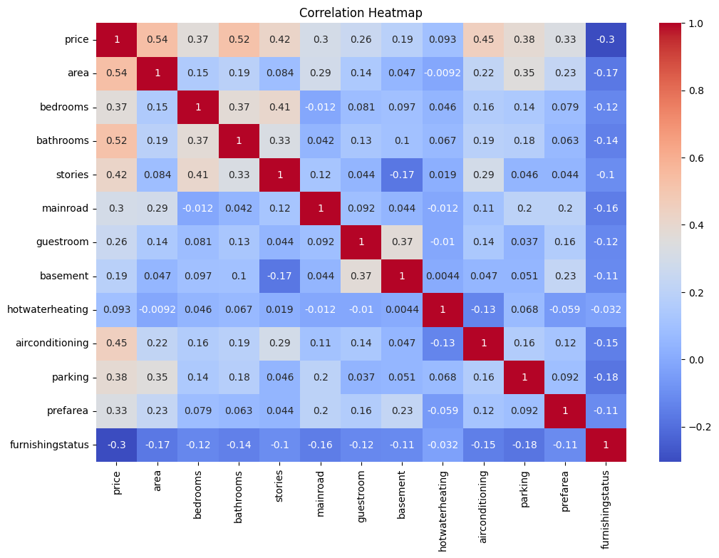 Figure 2: Distribution of House Prices (Histogram)
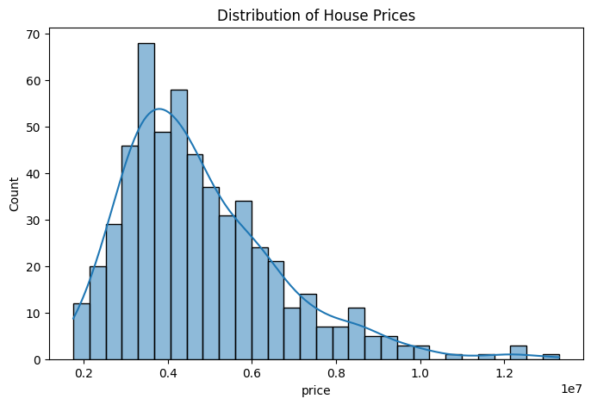
Figure 3: Scatter Plot of Area vs House Price
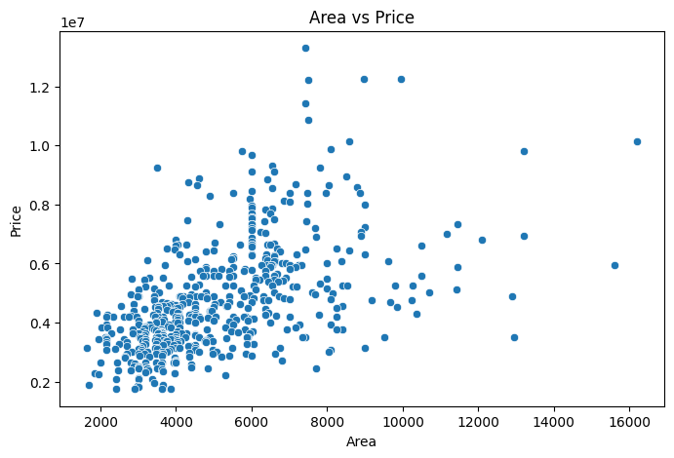
Figure 4: Boxplot of Furnishing Status vs House Price
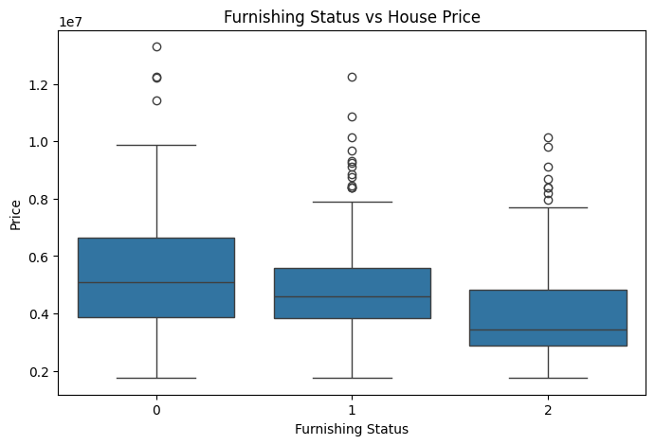
Figure 5: Boxplot of Air Conditioning vs House Price
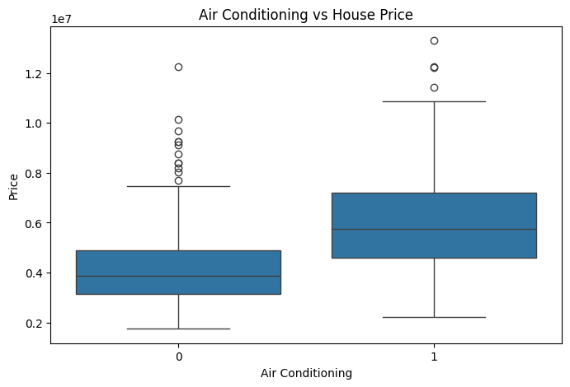
Figure 6: Pairplot Showing Relationships Between Area, Bedrooms, Bathrooms, and Price
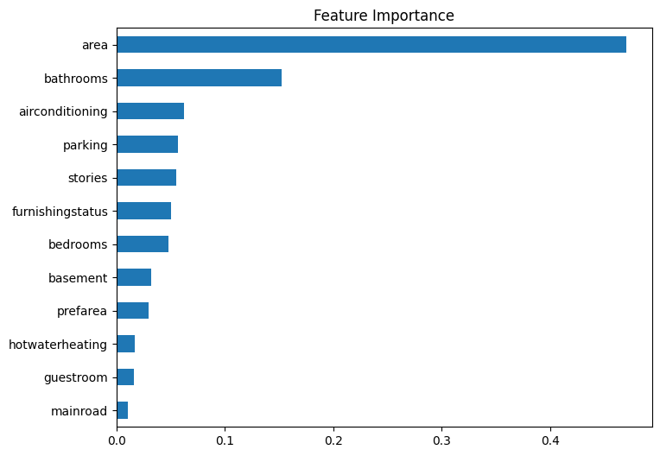
Figure 7: Actual vs Predicted House Prices (Linear Regression
